. . . BEGIN TRANSMISSION

HEADER
FROM: Delta Command, Fort Bragg
TO: Bravo One
SUBJECT: Enrico Ebanez

OVERVIEW
Congratulations. With help from 2nd Ranger, we have brought the drug cartel to its knees. Drug production in all of its factories has stopped and members are giving themselves up to the DEA and the Colombian government. The fatal blow would be to take away the druglord, Enrico Ebanez, and that is just what we are going to do.
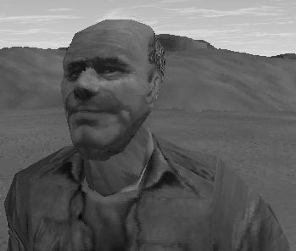

MISSION
Our spies within the cartel have informed us that Ebanez is planning to flee to Mexico. However, he is first going to stop at his hacienda and collect all of his personal files, most likely to keep the DEA from using it as evidence against him.
You will be inserted south of the hacienda by a Humvee. Because of the importance of this mission, we cannot give away the element of surprise by inserting by helo. Proceed north to hacienda, designated Checkpoint Charlie. Eliminate all guards outside, then proceed into the hacienda and capture Ebanez. Beware of enemy reinforcements, as well.
Also, you will notice that the druglord’s henchmen are dressed in civilian clothes. Do not confuse them with civilians. They are armed and dangerous. Do not hesitate to shoot them.

OBJECTIVES
- Capture the druglord
- Escort the druglord to the Extraction Point
- Reach the Extraction Point

WEATHER
Time: 0900 Hours, local time
Sky: Partly cloudy
Wind: None
Precipitation: None

NOTE
Due to NovaLogic’s inability to do anything right, there are no mission objectives or mission texts OR mission sounds that have the word “druglord” in them. Therefore, I have been forced to substitute with “general.”

END TRANSMISSION . . .

